**PROJECT PLAN:**

**Section 1:**

Mechanic1: Player can move and jump

Dynamic1: Player can navigate through obstacles and enemies and climb the mountain

Aesthetic1: Player uses skill to climb the mountain faster, when they climb the mountain faster, they feel rewarded.

Mechanic2: Player must pass a level to advance to the next.

Dynamic2: The player can get stuck on harder levels, but they will push through it to move to the next level.

Aesthetic2: The player can end up frustrated, causing them to stop playing, or if they pass the level, they will feel very satisfied.

Mechanic3: Player can attack enemies

Dynamic3: Player can defend themselves while climbing the mountain

Aesthetic3: Player uses skill to defend themselves against enemies and allow them to climb faster

Mechanic4: Background can only move upwards

Dynamic4: If a player falls through a hole on the bottom, the game will end.

Aesthetic4: The game is more challenging, and the player has to plan where to climb the mountain to avoid placing holes in bad locations.

Mechanic5: Obstacles in the background (like an icicle) can hurt the player

Dynamic5: Player must avoid obstacles while climbing the mountain

Aesthetic5: The game becomes more challenging since the player must avoid obstacles while climbing, a player with more skill will be able to avoid these obstacles more easily creating satisfaction after these obstacles are avoided.

**Section 2:**

* The game was previously a level-based game, we plan to update this by turning it into an infinite game where the score is tracked of how high you go. (Upon analysis of mechanic 2)
* We also plan to have different terrains, so as you go higher, the background and the enemy’s change. (Underground -> desert -> ice -> space)
* We may also add new enemies for each of the new terrains.
* If we do plan to make levels, we will probably make an aesthetic change where the game ends with the player reaching the top ground.
* Another aesthetic change that will result from these new mechanics is that the player will be able to just stop playing, since there is no time limit as it is endless, so we plan to make a mechanic for the block to break if you stand on it for more than an allotted timeframe.

**Section 3:**

We’re planning on rebranding our game by broadening the scope to just climbing instead of only ice climber. Right now, we’re planning on starting the climber underground. After they climb high enough, they will reach a desert surface level. After that they will reach ice mountains. Afterwards, the climber will reach space and will continue to travel as far as they can. In each scenario, there will be different obstacles and enemies to make traversing the terrain difficult.

Name Ideas

* Climber
* World Climber

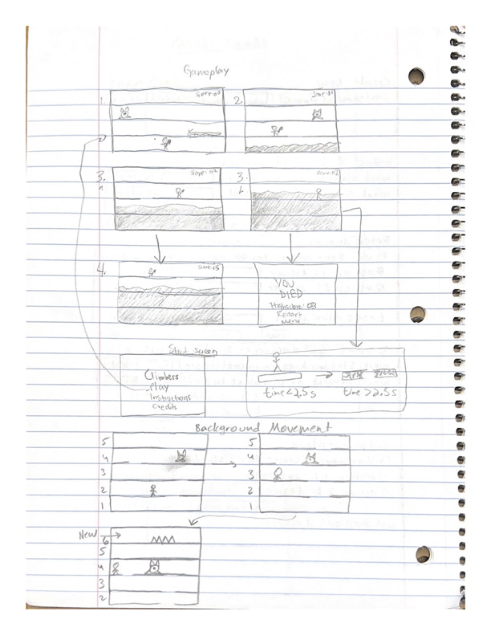

**Section 4:**

Must have:

* + the game randomly generates every next level (new height) of itself probably by utilizing randomness APIs (scrolling texture) – 12/25/21 - Dan
  + Scrolling Background, has a decreasing velocity as the user gets to the maximum of each jump (latter half is nice to have)-1/10 - Boaz
  + The game will also have to build new enemies on its own rather than each level being randomly created. This will also make use of the random API. – 1/10 - Boaz
  + A tracking of the player’s climb height (score) - 12/23/21 - Dan
  + Generate background, and change background, and platform textures and enemy textures based on the height – 1/10 - Nanda
  + As height progresses, the time on each block will decrease (breaking will ensue faster) to make the game more difficult -ateeq and
  + Animation and sprites-ateeq
  + UI details (score displaying, time, etc) - ateeq
  + Player movement and attacking (Physics) - Manish

Should have:

* + Near rising lava feature, would help incentivize player to keep going.
  + Obstacles in the terrain like icicles or asteroids
  + Players can get bonus points by collecting little trinkets/points or something else and those are added to the player’s overall score. – 12/21/21 - Dan
  + Enemies also get more difficult as terrain difficulty increases. We could add new enemies

Nice to have:

* Maybe there are different aesthetics for each checkpoint, like instead of ice, it is rocky, dirty, or even a crystal cave design.
* Powerups (Ex. Jump boost)
* 2 player mode (race to stay on the screen)
* World high score/leaderboard – 12/31/21 – Dan
* Changing the weapon based on terrain
* Moving platforms